502- MSc Computer Science

1. The postfix expression for the infix expression A + B * (C + D) / F + D * E is:
(A) | AB + CD + *F/D + E*
(B) | ABCD + *F/ + DE* +
(C) | A*B + CD/F*DE + +
(D) | A + *BCD/F*DE + +

2. Which of the following is essential for converting infix expression to postfix form efficiently?
(A) | An operator stack
(B) | An operand stack
(C) | An operator stack and an operand stack
(D) | No need of a stack

3. The following sequence of operation is performed on stack:
push(1),push(2),pop, push(1), push(2), pop, pop, pop, push(2), pop.
The sequence of popped out values is?
(A) | 2, 2, 1, 1, 2
(B) | 2, 2, 1, 2, 2
(C) | 2, 1, 2, 2, 1
(D) | 2, 1, 2, 1, 2

4. Stack can be implemented using ……………. and …………….
(A) | Trees and Linked List
(B) | Array and Graph
(C) | Linked list and Array
(D) | Queue and Graph

5. In a circular linked list organization, insertion of a record involves the assignment of
(A) | No pointer
(B) | 1 Pointer
(C) | 2 Pointers
(D) | 3 Pointers

6. Which of the following is not a type of constructor?
(A) | Copy constructor
(B) | Default constructor
(C) | Friend constructor
(D) | Parameterized constructor

7. Which of the following concept determines at runtime what method to invoke?
(A) | Dynamic Binding
(B) | Dynamic Loading
(C) | Dynamic Typing
(D) | Data Hiding

8. Which of the following two entities (reading from Left to Right) can be connected by the dot operator?
(A) | A class object and a member of that class
(B) | A class and a member of that class
(C) | A class member and a class object
(D) | A class object and a class

9. Which of the following is not an arithmetic operation?
(A) | a *= 10;
(B) | a /= 10;
(C) | a != 10;
(D) | a %= 10;

10. What is the output of this C code?
#include <stdio.h>
void main()
{
double k = 0;
for (k = 0.0; k < 3.0; k++)
printf("Hello");
}
(A) | Run time error
(B) | Hello is printed thrice
(C) | Hello is printed twice
(D) | Hello is printed infinitely

11. Relational operators can be used on
(A) | structure
(B) | long
(C) | string
(D) | float

12. What is the output of this C code?
#include <stdio.h>
void main()
{
int k;
for (k = -3; k < -5; k++)
printf("Hello");
}
(A) | Hello
(B) | Infinite Hello
(C) | Run time error
(D) | Nothing

13. #include <stdio.h>
int main()
{
int i = 0;
for (; ; ;)
printf("In for loop\n");
printf("After loop\n");
}
Output of above code
(A) | compile error
(B) | infinite loop
(C) | after loop
(D) | undefined behaviour

14. If a process needs I/O to or from a disk, and if the drive or controller is busy then:
(A) | the request will be placed in the queue of pending requests for that drive
(B) | the request will not be processed and will be ignored completely
(C) | the request will not be placed
(D) | None of the above

15. SSTF algorithm, like SJF …………… of some requests.
(A) | may cause starvation
(B) | will cause starvation
(C) | does not cause starvation
(D) | causes aging

16. The part of machine level instruction, which tells the central processor what has to be done, is
(A) | Operation code
(B) | Address
(C) | Locator
(D) | Flip-Flop

17. Which of the following refers to the associative memory?
(A) | The address of the data is generated by the CPU
(B) | The address of the data is supplied by the users
(C) | There is no need for an address i.e. the data is used as an address
(D) | The data are accessed sequentially

18. To avoid the race condition, the number of processes that may be simultaneously inside their critical section is
(A) | 8
(B) | 1
(C) | 16
(D) | 0

19. Process is
(A) | program in High level language kept on disk
(B) | contents of main memory
(C) | a program in execution
(D) | a job in secondary memory

20. Which of the following system software does the job of merging the records from two files into one?
(A) | Security software
(B) | Utility program
(C) | Networking software
(D) | Documentation system

21. Which of the following instruction steps, would be written within the diamond-shaped box, of a flowchart?
(A) | S = B – C
(B) | IS A < 10
(C) | PRINT A
(D) | DATA X, 4Z

22. Interprocess communication
(A) | is required for all processes
(B) | is usually done via disk drives
(C) | is never necessary
(D) | allows processes to synchronize activity

23. A system program that sets up an executable program in main memory, ready for execution is
(A) | Assembler
(B) | Linker
(C) | Loader
(D) | Compiler

24. Which of the following are loaded into main memory when the computer is booted?
(A) | Internal command instructions
(B) | External command instructions
(C) | Utility programs
(D) | Word processing instructions

25. The FIFO algorithm
(A) | executes first the job that last entered the queue
(B) | executes first the job that first entered the queue
(C) | executes first the job that has been in the queue the longest
(D) | executes first the job with the least processor needs

26. Which of the following is not a logical data-base structure?
(A) | Tree
(B) | Relational
(C) | Network
(D) | Chain

27. Which of the following are the applications of stack?
(A) | Function calls
(B) | Large number Arithmetic
(C) | Evaluation of arithmetic expressions
(D) | All of the above

28. If the post order traversal of a binary tree is DEBFCA, find the pre order traversal
(A) | ABFCDE
(B) | ADBFEC
(C) | ABDECF
(D) | ABDCEF

29. If several elements are competing for the same bucket in the hash table, what is it called?
(A) | Diffusion
(B) | Replication
(C) | Collision
(D) | Chaining

30. In linked list implementation of a queue, if front and rear pointers are tracked, which of these pointers will change during an insertion into a NONEMPTY queue?
(A) | Only front pointer
(B) | Only rear pointer
(C) | Both front and rear pointer
(D) | No change

31. Consider the following operation performed on a stack of size 5.
Push(1);
Pop();
Push(2);
Push(3);
Pop();
Push(4);
Pop();
Pop();
Push(5);
After the completion of all operation, the number of elements present in stack are
(A) | 1
(B) | 2
(C) | 3
(D) | 4

32. Which of the following is the postfix expression of the given infix expression converted using a stack?
x + y * z + (p * q + r) * s
(A) | xyz * + pq * r + s * +
(B) | xyz * + pq * r + s + *
(C) | xyz + * pq * r + s * +
(D) | None of the above

33. The strategy of allowing processes that are logically runnable to be temporarily suspended is called
(A) | preemptive scheduling
(B) | non preemptive scheduling
(C) | shortest job first
(D) | first come first served

34. The data transfer operation that is done without using the CPU is called
(A) | Program controlled data transfer
(B) | Interrupt controlled data transfer
(C) | Direct memory access data transfer
(D) | Bidirectional data transfer

35. The height of tree is the length of the longest root-to-leaf path in it. The maximum and minimum number of nodes in a binary tree of height 5 are
(A) | 63 and 6 respectively
(B) | 64 and 5 respectively
(C) | 32 and 6 respectively
(D) | 31 and 5 respectively

36. Which member function of class cannot modify its objects’ attributes?
(A) | Friend functions
(B) | Private member functions
(C) | Static member functions
(D) | Constant member functions

37. What is the minimum number of two-input NAND gates used to perform the function of two input OR gate?
(A) | One
(B) | Two
(C) | Three
(D) | Four

38. The ability to modify the database schema without causing changes to existing application programs is called ............... data independence.
(A) | Logical
(B) | Physical
(C) | View
(D) | None of the above

39. Which of the following is another name of primary index?
(A) | Secondary index
(B) | Random index
(C) | Clustering index
(D) | None of the above

40. If an entity set does not have sufficient attributes to form a primary key, it is called as a ............... entity set.
(A) | Weak
(B) | Dependent
(C) | Partial
(D) | None of the above

41. Given the basic ER and relational models, which of the following is INCORRECT?
(A) | An attribute of an entity can have more than one value
(B) | An attribute of an entity can be composite
(C) | In a row of a relational table, an attribute can have more than one value
(D) | In a row of a relational table, an attribute can have exactly one value or a NULL value

42. The set of all allowable values that an attribute of a record can take is called as
(A) | Fields
(B) | Domain
(C) | Constraint
(D) | None of the above

43. Groups of data items or records that are physically stored and retrieved together is called as
(A) | Cluster
(B) | Blocks
(C) | Index
(D) | None of the above

44. What will be the number of columns of a Cartesian product if the participating relations have 3 and 4 fields each?
(A) | 3
(B) | 4
(C) | 12
(D) | 7

45. What is a DFD?
(A) | The modern version of flowchart
(B) | Mainly used at systems specification stage
(C) | The primary output of the system design phase
(D) | All of the above

46. Which one of the following is an application of Queue Data Structure?
(A) | When a resource is shared among multiple consumers.
(B) | When data is transferred asynchronously (data not necessarily received at same rate as sent) between two processes
(C) | Load Balancing
(D) | All of the above

47. Which of the following sorting algorithms can be used to sort a random linked list with minimum time complexity?
(A) | Insertion Sort
(B) | Quick Sort
(C) | Heap Sort
(D) | Merge Sort

48. The concatenation of two lists is to be performed in O(1) time. Which of the following implementations of a list should be used?
(A) | Singly linked list
(B) | Doubly linked list
(C) | Circular doubly linked list
(D) | Array implementation of lists

49. Identify the incorrect file opening mode from the following.
(A) | r
(B) | x
(C) | w
(D) | A

50. Which of the data types has the size that varies?
(A) | int
(B) | struct
(C) | float
(D) | double

51. What are the things inherited from the base class?
(A) | Constructor and its destructor
(B) | Operator=() members
(C) | Friends
(D) | All of the mentioned

52. Consider the statement, int val[2][4] = {1, 2, 3, 4, 5, 6, 7, 8}; 4 will be the value of
(A) | val [1][4]
(B) | val [0][4]
(C) | val [1][1]
(D) | None of the above

53. If integer needs two bytes of storage, then maximum value of a signed integer is
(A) | 2¹⁶ – 1
(B) | 2¹⁵ – 1
(C) | 2¹⁶
(D) | 2¹⁵

54. Which of the following is the output for the given program fragment?
int a = 4, b = 6;
printf(“% d”, a = = b);
(A) | Outputs an error message
(B) | Prints 0
(C) | Prints 1
(D) | None of the above

55. The statement printf(“%d”, 10?0?5:11:12); prints
(A) | 10
(B) | 0
(C) | 12
(D) | 11

56. In the following program
main()
{
float a = .5, b = .7;
if (b < = 0.7)
if (a < 0.5)
printf(“KCET”);
else
printf(“CUSAT”);
else
printf(“CET”);
}
Output is
(A) | CUSAT
(B) | KCET
(C) | CET
(D) | None of the above

57. Consider the following program segment in C
main()
{
printf(“CUSAT”);
main();
}
(A) | is illegal
(B) | keeps on printing CUSAT
(C) | prints CUSAT once
(D) | None of the above

58. #include<stdio.h>
int main(){
int k = 5;
if(5 == k)
printf("%d",k<<2<<1);
else
printf("Not equal");
}
(A) | 1
(B) | 48
(C) | 40
(D) | Compiler error

59. #include<stdio.h>
int main(){
int i=11;
int const * p=&i;
p++;
printf("%d",*p);
return 0;
}
(A) | 11
(B) | 12
(C) | Garbage value
(D) | Compiler error

60. #include<stdio.h>
int main(){
int array[2][2][3]={0,1,2,3,4,5,6,7,8,9,10,11};
printf("%d",array[1][0][2]);
return 0;
}
(A) | 5
(B) | 7
(C) | 8
(D) | 6

61. What does polymorphism in OOPs mean?
(A) | Concept of allowing overriding of functions
(B) | Concept of hiding data
(C) | Concept of keeping things in different modules/files
(D) | Concept of wrapping things into a single unit

62. Which concept allows you to reuse the written code?
(A) | Encapsulation
(B) | Abstraction
(C) | Inheritance
(D) | Polymorphism

63. When destructors are called?
(A) | When a program ends
(B) | When a function ends
(C) | When a delete operator is used
(D) | All of the mentioned

64. What happens if a user forgets to define a constructor inside a class?
(A) | Error occurs
(B) | Segmentation fault
(C) | Objects are not created properly
(D) | Compiler provides a default constructor to avoid faults/errors

65. Why do we need to handle exceptions?
(A) | To avoid unexpected behaviour of a program during run-time
(B) | To let compiler remove all exceptions by itself
(C) | To successfully compile the program
(D) | To get correct output

66. Which alternative can replace the throw statement?
(A) | for
(B) | break
(C) | return
(D) | exit

67. What is the use of RAII in C++ programming?
(A) | Improve the exception safety
(B) | Terminate the program
(C) | Exit from the block
(D) | Crash the compiler

68. Which of the following is true?
(A) | Static methods cannot be overloaded
(B) | Static data members can only be accessed by static methods
(C) | Non-static data members can be accessed by static methods
(D) | Static methods can only access static members (data and methods)

69. A machine needs a minimum of 100 sec to sort 1000 names by quick sort. The minimum time needed to sort 100 names will be approximately
(A) | 50.2
(B) | 6.7
(C) | 72.7
(D) | 11.2

70. Which of the following is the average number of key comparisons done by sequential search in the successful case?
(A)
(B)
(C) | n + 1
(D) | 2n

71. Which of the following is asymptotically smaller?
(A) | lg(lg*n)
(B) | lg*(lgn)
(C) | lg(n!)
(D) | lg*(n!)

72. What is recurrence for worst case of Quicksort and what is the time complexity in worst case?
(A) | Recurrence is T(n) = T(n – 2) + O(n) and time complexity is O(n²)
(B) | Recurrence is T(n) = T(n – 1) + O(n) and time complexity is O(n²)
(C) | Recurrence is T(n) = 2T(n/2) + O(n) and time complexity is O(n log n)
(D) | Recurrence is T(n) = T(n/10) + T(9n/10) + O(n) and time complexity is O(n log n)

73. Which one of the following in place sorting algorithms needs the minimum number of swaps?
(A) | Quick sort
(B) | Insertion sort
(C) | Selection sort
(D) | Heap sort

74. Which of the following is true about Huffman Coding?
(A) | Huffman coding may become lossy in some cases
(B) | Huffman codes may not be optimal lossless codes in some cases
(C) | In Huffman coding, no code is prefix of any other code
(D) | All of the above

75. Which of the following expression accesses the (i, j)^{th} entry of a (M × N) matrix stored in column major form?
(A) | N(i – 1) + j
(B) | M(j – 1) + i
(C) | M(N – j) + j
(D) | N(M – i) + j

76. A binary tree T has n leaf nodes. The number of nodes of degree 2 in T is
(A) | log₂ n
(B) | n − 1
(C) | n
(D) | 2n

77. The post fix form of A$B*C – D + E/F/(G + H)
(A) | AB$C*D – EF/GH+/+
(B) | AB$C – D + EF/GH/+
(C) | AB$C + D – EF/GH–/+
(D) | AB$C – D*EF/GH/++

78. A complete binary tree of level 5 has how many nodes? (Assume root node at level 0)
(A) | 15
(B) | 25
(C) | 63
(D) | 33

79. Which of the following operations is not O(1) for an array of sorted data. You may assume that array elements are distinct?
(A) | Find the i^{th} largest element
(B) | Delete an element
(C) | Find the i^{th} smallest element
(D) | All of the above

80. Which data structure is used for balancing of symbols in an expression?
(A) | Stack
(B) | Queue
(C) | Tree
(D) | Graph

81. Which of the following data structures is best suited for efficient implementation of priority queue?
(A) | Array
(B) | Linked List
(C) | Heap
(D) | Stack

82. The minimum number of stacks needed to implement a queue is
(A) | 3
(B) | 1
(C) | 2
(D) | 4

83. Given the following prefix expression: * + 3 + 3 ↑ 3 + 3 3 3. What is the value of the prefix expression?
(A) | 2178
(B) | 2199
(C) | 2205
(D) | 2232

84. Which normal form considered adequate for relational database design?
(A) | 2 NF
(B) | 3 NF
(C) | 4 NF
(D) | BCNF

85. If every non-key attribute is only functionally dependent on the primary key, then the relation will be in
(A) | 1 NF
(B) | 2 NF
(C) | 3 NF
(D) | 4 NF

86. A data model is a collection of conceptual tools for describing
(A) | Data ad data relationship
(B) | Data semantics and consistency constraints
(C) | Data, data relationship, data semantics and consistency constraints
(D) | None of the above

87. A trigger is
(A) | a statement that enables to start any DBMS
(B) | a statement that is executed by the user when debugging an application program
(C) | a condition the system tests for the validity of the database user
(D) | a statement that is executed automatically by the system as a side effect of a modification to the database

88. Generally speaking, for a week entity set to be meaningful it must be part of a
(A) | one-to-one relationship
(B) | one-to-many relationship
(C) | many-to- many relationship
(D) | None of the above

89. Assume transaction A holds a shared lock R. If transaction B also requests for a shared lock on R, it will
(A) | result in a deadlock situation
(B) | immediately be granted
(C) | immediately be rejected
(D) | be granted as soon as it is released by A

90. Which of the following is not usually part of the responsibilities of a database administrator?
(A) | Approving structural changes to the database
(B) | Designing data entry screens
(C) | Ensuring that an adequate back-up regime in place
(D) | Issuing account to users and monitoring the performance of the system

91. The way a particular view the data from the database that an application uses is
(A) | Module
(B) | Relation
(C) | Schema
(D) | Subschema

92. Which of the following operations is not part of the five basic set operations in relational algebra?
(A) | Union
(B) | Division
(C) | Cartesian Product
(D) | Set Difference

93. Which of the following statements concerning relational database is true?
(A) | A foreign key field may be null
(B) | A primary key field may be null
(C) | All relations must be in at least third normal form
(D) | The primary key fields of a relation must be adjacent

94. Relation R has attributes A, B, C, D, E, F, G, H, I, J and satisfies FD’S
ABD E
C J
AB G
CI I
B F
G HI
Find the candidate key.
(A) | ABCI
(B) | ABCDG
(C) | ABCDE
(D) | ABCD

95. The page replacement policy that sometimes leads to more page faults when the size of the memory is increased is
(A) | FIFO
(B) | LRU
(C) | No such policy exists
(D) | None of the above

96. Kernel is
(A) | considered as the critical part of the operating system
(B) | the software which monitors the operating system
(C) | the set of primitive functions upon which the rest of operating system functions are built up
(D) | None of the above

97. In a time-sharing operating system, when the time slot given to a process is completed, the process goes from the RUNNING state to the
(A) | BLOCKED state
(B) | READY state
(C) | SUSPENDED state
(D) | TERMINATED state

98. Virtual memory is
(A) | part of main memory only used for swapping
(B) | a technique to allow a program, of size more than the size of main memory, to run
(C) | part of secondary storage used in program execution
(D) | None of the above

99. A process executes the code
fork();
fork();
fork();
The total number of child processes created is
(A) | 3
(B) | 4
(C) | 7
(D) | 8

100. What problem is solved by Dijkstra banker’s algorithm?
(A) | Cache coherence
(B) | Mutual exclusion
(C) | Deadlock recovery
(D) | Deadlock avoidance

101. Find out which of the figures (1), (2), (3) and (4) can be formed from the pieces given in figure (X).
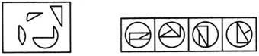
(X) | (1) | (2) | (3) | (4)

(A) | 1
(B) | 2
(C) | 3
(D) | 4

102. Find the number of triangles in the given figure.
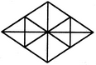
(A) | 16
(B) | 22
(C) | 28
(D) | 32

103. Identify the figure that completes the pattern.
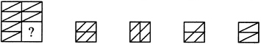
(X) | (1) | (2) | (3) | (4)

(A) | 1
(B) | 2
(C) | 3
(D) | 4

104. Identify the figure that completes the pattern.
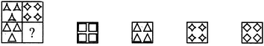
(X) | (1) | (2) | (3) | (4)

(A) | 1
(B) | 2
(C) | 3
(D) | 4

105. Identify the figure that completes the pattern.
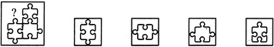
(X) | (1) | (2) | (3) | (4)

(A) | 1
(B) | 2
(C) | 3
(D) | 4

106. Look at this series: 22, 21, 23, 22, 24, 23, ………. What number should come next?
(A) | 22
(B) | 24
(C) | 25
(D) | 26

107. Look at this series: 664, 332, 340, 170, ………, 89. What number should fill the blank?
(A) | 85
(B) | 97
(C) | 109
(D) | 178

108. A person crosses a 600 m long street in 5 minutes. What is his speed in km per hour?
(A) | 3.6
(B) | 7.2
(C) | 8.4
(D) | 10

109. If a person walks at 14 km/hr instead of 10 km/hr, he would have walked 20 km more. The actual distance travelled by him is:
(A) | 50 km
(B) | 56 km
(C) | 70 km
(D) | 80 km

110. The angle of elevation of a ladder leaning against a wall is 60° and the foot of the ladder is 4.6 m away from the wall. The length of the ladder is:
(A) | 2.3 m
(B) | 4.6 m
(C) | 7.8 m
(D) | 9.2 m

111. Which one of the following is not a prime number?
(A) | 31
(B) | 61
(C) | 71
(D) | 91

112. The largest 4 digit number exactly divisible by 88 is:
(A) | 9944
(B) | 9768
(C) | 9988
(D) | 8888

113. A number when divided by 296 leaves 75 as remainder. When the same number is divided by 37, the remainder will be:
(A) | 1
(B) | 2
(C) | 8
(D) | 11

114. A number, divided by 6 leaves a remainder 3. When the square of that number is divided by 6, the remainder is:
(A) | 0
(B) | 1
(C) | 2
(D) | 3

115. Find the value of a/(b + a/(b + a/(b – a/b))) where the value of a = 1 and b =3
(A) | 3/10
(B) | 10/3
(C) | 27/89
(D) | 89/27

116. The ratio of two numbers is 4:7 and their HCF is 6. Find the LCM.
(A) | 84
(B) | 1008
(C) | 132
(D) | 168

117. The difference between a two-digit number and the number obtained by interchanging the positions of its digits is 36. What is the difference between the two digits of that number?
(A) | 3
(B) | 4
(C) | 5
(D) | 6

118. Find a positive number which when increased by 17 is equal to 60 times the reciprocal of the number.
(A) | 3
(B) | 10
(C) | 17
(D) | 20

119. If A is the son of Q, Y and Q are sisters, Z is the mother of Y, P is the son of Z, then which of the following statements is correct?
(A) | P is the maternal uncle of A
(B) | A and P are cousins
(C) | P and Y are sisters
(D) | Z and Y are parents of A

120. Looking at a photograph, Ram says “His mother is the wife of my father’s son. I don’t have any brothers or sisters”. How is the person in the photograph related to Ram?
(A) | His cousin
(B) | His son
(C) | His father
(D) | His uncle

121. Fill in the next pattern
ZA1, 3YB, C5X, WD7,………
(A) | V9E
(B) | VE9
(C) | EV9
(D) | 9VE

Directions: Study the diagram below and answer the questions. Triangle represents doctors, circle represents players and rectangle represents artists.
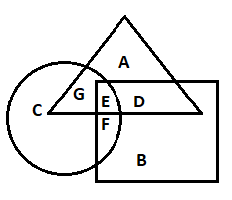
122. What does letter D represent?
(A) | Doctors who are players
(B) | Artists who are doctors
(C) | Doctors who are not artists
(D) | Players who are not doctors

123. Players who are doctors but not artist is represented by
(A) | A
(B) | E
(C) | G
(D) | F

124. Which letter represents artists who are neither doctor nor player?
(A) | A
(B) | G
(C) | F
(D) | B

125. How many rectangles are there in the figure?

(A) | 6
(B) | 7
(C) | 8
(D) | 9

126. Find the term which do not fit into the series G4T, J10R, M20P, P43N, S90L.
(A) | G4T
(B) | J10R
(C) | M20P
(D) | S90L

Directions: Use the following figure to answer questions.
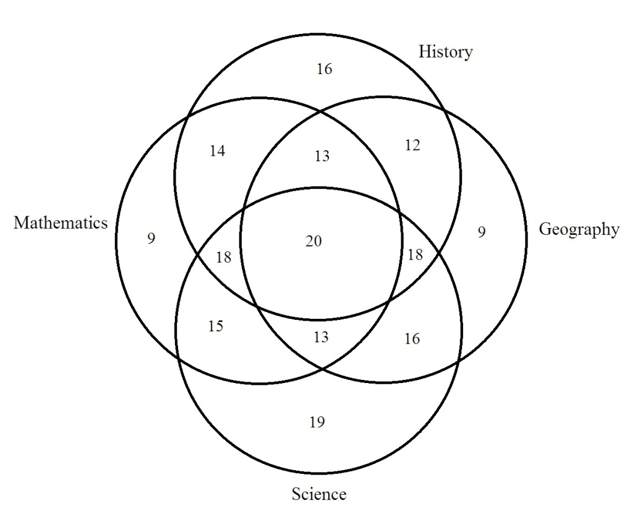
127. The number of students who took any three of the above subjects was
(A) | 62
(B) | 63
(C) | 64
(D) | 66

128. The number of students who took both History and Geography among other subjects was
(A) | 62
(B) | 63
(C) | 65
(D) | 66

129. Which subject was taken by the largest number of students?
(A) | Mathematics
(B) | Science
(C) | Geography
(D) | History

130. Select a suitable figure from the four alternatives that would complete the figure matrix.
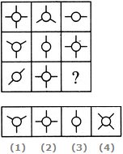
(A) | 1
(B) | 2
(C) | 3
(D) | 4

131. Select a suitable figure from the four alternatives that would complete the figure matrix.
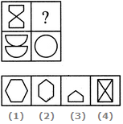
(A) | 1
(B) | 2
(C) | 3
(D) | 4

132. Select a suitable figure from the four alternatives that would complete the figure matrix.
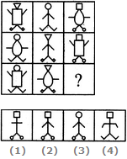
(A) | 1
(B) | 2
(C) | 3
(D) | 4

133. Select a suitable figure from the four alternatives that would complete the figure matrix.
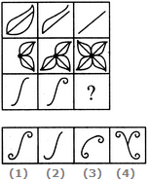
(A) | 1
(B) | 2
(C) | 3
(D) | 4

134. Select a suitable figure from the four alternatives that would complete the figure matrix.
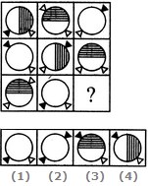
(A) | 1
(B) | 2
(C) | 3
(D) | 4

135. Select a suitable figure from the four alternatives that would complete the figure matrix.
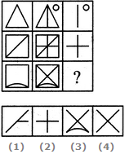
(A) | 1
(B) | 2
(C) | 3
(D) | 4

136. What is the missing number in the following sequence?
2, 12, 60, 240, 720, 1440, ....
(A) | 2880
(B) | 1440
(C) | 720
(D) | 0

137. Choose the missing number in the series: 9, 7, 12, 12, 15, 17, 18, 22, ?
(A) | 27
(B) | 21
(C) | 22
(D) | 24

138. Which one will replace the question mark in the given series?
1, 9, 25, 49, ?, 121
(A) | 100
(B) | 91
(C) | 64
(D) | 81

139. Which one will replace the question mark in the given series.
6, 11, 21, 36, 56, ?
(A) | 91
(B) | 81
(C) | 51
(D) | 42

140. Find the missing number in the series. 8, 27, 125, …..…,1331.
(A) | 512
(B) | 216
(C) | 343
(D) | 169

141. Find the missing number in the series. 1, 8, 4, 27, 9, ?
(A) | 8
(B) | 9
(C) | 64
(D) | 16

142. Find the missing values in the series. 3, 6, 8, 16, 18, ?
(A) | 28
(B) | 36
(C) | 54
(D) | 34

143. A man walks 1 KM to east and then he turns to south and walks a distance of 5 KM. Again, he turns to east and walks 2 KM. After this he turns to North and walks 9 KM. now how far is he from his starting point?
(A) | 3
(B) | 4
(C) | 5
(D) | 7

144. The product of the complex numbers (4, 3) and (–7, 6) is?
(A) | (–46, 3)
(B) | (46, –3)
(C) | (46, 3)
(D) | (3, 46)

145. The value of log₂ 16 is:
(A)
(B) | 4
(C) | 8
(D) | 16

146. If log_{x} y = 100 and log₂ x = 10, then the value of y is:
(A) | 2¹⁰
(B) | 2¹⁰⁰
(C) | 2¹⁰⁰⁰
(D) | 2¹⁰⁰⁰⁰

147. | A | They fled to the higher ground
 | B | Soon the floods retired and the villagers were able to return
 | C | The river overflowed its banks
 | D | The rain fell steadily for several days
 | E | The terrified villagers abandoned their homes
The proper sequence should be:
(A) | CEBAD
(B) | DEBCA
(C) | DCEAB
(D) | EDABC

148. The next term in the series ABD, DGK HMS MTB SBL …….… is
(A) | ZKU
(B) | ZCA
(C) | ZKW
(D) | KZU

149. Select a suitable figure from the four alternatives that would complete the figure matrix.
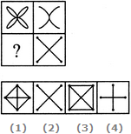
(A) | 1
(B) | 2
(C) | 3
(D) | 4

150. Select a suitable figure from the four alternatives that would complete the figure matrix.
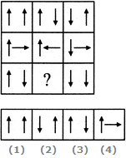
(A) | 1
(B) | 2
(C) | 3
(D) | 4

